

Windows Lab 9

ITSC 200: Network Protocols and Security

Table of Contents

Lab Outcome(s) 2

Reading 2

Introduction 2

1. Installing Windows 10 and adding it to the domain 3

References 4

Lab Outcome(s)

* Install Windows 10 and add it to the Windows Server 2016 domain.
* Review a Wireshark capture of an SMB session.

Reading

* None

Introduction

This lab is to practice the installation of Windows 10 in a virtual machine and the adding of a workstation to an existing Active Directory domain running on Windows Server 2016. It also looks at a detailed capture of an SMB file sharing session.

1. Installing Windows 10  
   1. Create a new virtual machine in Virtualbox  
      1. Set the Operating System type to Windows 10 64bit
      2. Set RAM to 4 GB.
      3. Set the networking to NAT (for now).
      4. Set the disk space to dynamic and 40 GB.
      5. Attach the Windows 10 ISO to the virtual CDROM
   2. Start the VM. (Install Windows professional, not Windows Home edition)
   3. Once the install is complete, check the IP address, subnet mask, DNS, and default gateway.
   4. Set the static IP information to match the dynamically supplied information above.
   5. Allow the updates to be installed (this will take a while).
   6. Create a snapshot of the VM once all of the updates have completed and you reboot the Windows 10 VM.
   7. Make sure you can access the Internet once you reboot.
   8. Once you have rebooted the Windows 10 VM, change the DNS server that it is using to be the IP address of your Windows 2016 VM.
   9. Add the workstation to the existing Active Directory Domain running on the Windows Server 2016 VM. You will need your AD administrator account and password to do this.
   10. You should also create a new regular AD user.
   11. Once the workstation has been added to the domain, notice that your login has changed. You now need to preface your username with the domain name.
   12. Create a new directory on your Windows server ([c:\myshare](../../../../../../../../c:/myshare))and create a new file in the directory.
   13. Set the NTFS permissions to give your new AD user Read access to the directory and file(s).
   14. Install Wireshark on your new Windows 10 VM. You may need to add a secondary DNS server address (8.8.8.8) to Windows 10 VM.
   15. Create a new share pointing to your new directory and give your new user Read and Write access to the share.
   16. Log into your new workstation start a new Wireshark capture.
   17. Using the command line, connect to your new share.
   18. Go to the file manager in your workstation. What is your new drive letter ?
   19. Try to create a new file in the share. What was the result ? Why ?
   20. Stop your Wireshark capture.
   21. What destination port does SMB use to connect to your share ?
   22. Follow the TCP Stream on the SMB traffic and what can you see that might be a security problem on a corporate network ?
   23. Close or suspend your VM.
   24. We will use this VM in the next couple of classes but if you want to play with it in the meantime, make sure that you return to your snapshot after so that you have a clean install when we start working with it later.

For this lab, submit a screen capture of your Windows 10 workstation after it has been joined to the domain. (Lab 9 OS Assignment (D2L))

An example screen capture is pictured below.

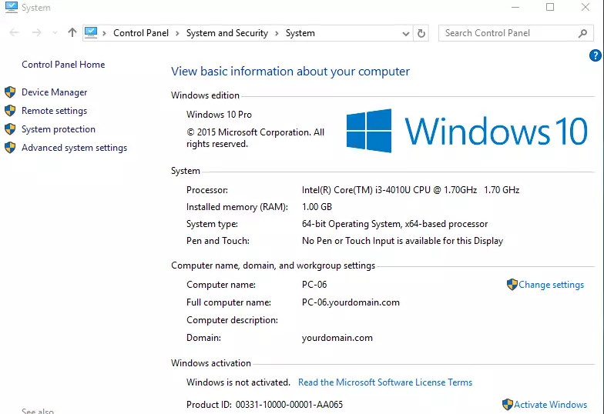

References

Add a Windows 10 Workstation to the Domain

https://www.server-world.info/en/note?os=Windows_Server_2016&p=active_directory&f=8

Blank page if necessary to make pages an even number

**DO NOT DELETE THE SECTION BREAK BELOW. DELETING IT MAY IMPACT THE FORMATTING IN THIS DOCUMENT.**